
НЕГОСУДАРСТВЕННОЕ ОБРАЗОВАТЕЛЬНОЕ ЧАСТНОЕ УЧРЕЖДЕНИЕ ВЫСШЕГО ОБРАЗОВАНИЯ «УНИВЕРСИТЕТ “СИНЕРГИЯ”»

Факультет/Институт |  | Информационных технологий
 |  | (наименование факультета/ Института)
Направление/специальность |  | Прикладная информатика
подготовки: |  | (код и наименование направления /специальности подготовки)
Форма обучения: |  | очная
 |  | (очная, очно-заочная, заочная)

Отчет по лабораторной работе № 4
на тему |  | Файловый ввод-вывод
 |  | (наименование темы)
по дисциплине |  |  |  | Программное обеспечение носимых устройств
 |  |  |  | (наименование дисциплины)

Обучающийся |  | Соловьев Илья Александрович
 |  | (ФИО)
Группа |  | VДМП-101уцп

Преподаватель |  | Сибирев И. В.
 |  | (ФИО)

Дата предоставления отчета – «04» 03 2026 г.

Задание 1
Вариант 3
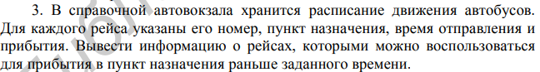
Код программы
void task_10() {
struct Bus {
int number;
char destination[100];
char departure[6];
char arrival[6];
};
int n;
char filename[100];
int choice;
std::cout << "\nTask 10: Bus schedule" << std::endl;
std::cout << "======================" << std::endl;
std::cout << "1 - Enter new data" << std::endl;
std::cout << "2 - Load from file" << std::endl;
std::cout << "Choose: ";
std::cin >> choice;
Bus* buses = NULL;
if (choice == 1) {
std::cout << "Enter number of buses: ";
std::cin >> n;
buses = new Bus[n];
for (int i = 0; i < n; i++) {
std::cout << "\nBus " << i + 1 << ":" << std::endl;
std::cout << "Route number: ";
std::cin >> buses[i].number;
std::cout << "Destination: ";
std::cin.ignore();
std::cin.getline(buses[i].destination, 100);
std::cout << "Departure time (HH:MM): ";
std::cin >> buses[i].departure;
std::cout << "Arrival time (HH:MM): ";
std::cin >> buses[i].arrival;
}
std::cout << "\nEnter filename to save: ";
std::cin >> filename;
FILE* file;
fopen_s(&file, filename, "w");
fprintf(file, "%d\n", n);
for (int i = 0; i < n; i++) {
fprintf(file, "%d\n%s\n%s\n%s\n",
buses[i].number,
buses[i].destination,
buses[i].departure,
buses[i].arrival);
}
fclose(file);
std::cout << "Data saved to " << filename << std::endl;
}
else {
std::cout << "Enter filename to load: ";
std::cin >> filename;
FILE* file;
fopen_s(&file, filename, "r");
if (file == NULL) {
std::cout << "Error opening file!" << std::endl;
return;
}
fscanf_s(file, "%d\n", &n);
buses = new Bus[n];
for (int i = 0; i < n; i++) {
fscanf_s(file, "%d\n", &buses[i].number);
fgets(buses[i].destination, 100, file);
buses[i].destination[strlen(buses[i].destination) - 1] = '\0'; // убираем \n
fgets(buses[i].departure, 6, file);
buses[i].departure[strlen(buses[i].departure) - 1] = '\0';
fgets(buses[i].arrival, 6, file);
buses[i].arrival[strlen(buses[i].arrival) - 1] = '\0';
}
fclose(file);
std::cout << "Data loaded from " << filename << std::endl;
}
std::cout << "\nAll buses:" << std::endl;
std::cout << "------------------------------------------------" << std::endl;
std::cout << "Route\tDestination\tDeparture\tArrival" << std::endl;
std::cout << "------------------------------------------------" << std::endl;
for (int i = 0; i < n; i++) {
std::cout << buses[i].number << "\t"
<< buses[i].destination << "\t\t"
<< buses[i].departure << "\t\t"
<< buses[i].arrival << std::endl;
}
char target_time[6];
std::cout << "\nEnter target arrival time (HH:MM): ";
std::cin >> target_time;
int target_h, target_m;
sscanf_s(target_time, "%d:%d", &target_h, &target_m);
int target_minutes = target_h * 60 + target_m;
std::cout << "\nBuses arriving before " << target_time << ":" << std::endl;
std::cout << "------------------------------------------------" << std::endl;
FILE* result_file;
fopen_s(&result_file, "result.txt", "w");
fprintf(result_file, "Buses arriving before %s:\n", target_time);
fprintf(result_file, "------------------------------------------------\n");
fprintf(result_file, "Route\tDestination\tDeparture\tArrival\n");
fprintf(result_file, "------------------------------------------------\n");
std::cout << "Route\tDestination\tDeparture\tArrival" << std::endl;
bool found = false;
for (int i = 0; i < n; i++) {
int arr_h, arr_m;
sscanf_s(buses[i].arrival, "%d:%d", &arr_h, &arr_m);
int arr_minutes = arr_h * 60 + arr_m;
if (arr_minutes < target_minutes) {
found = true;
std::cout << buses[i].number << "\t"
<< buses[i].destination << "\t\t"
<< buses[i].departure << "\t\t"
<< buses[i].arrival << std::endl;
fprintf(result_file, "%d\t%s\t\t%s\t\t%s\n",
buses[i].number,
buses[i].destination,
buses[i].departure,
buses[i].arrival);
}
}
if (!found) {
std::cout << "No buses found" << std::endl;
fprintf(result_file, "No buses found\n");
}
fclose(result_file);
std::cout << "\nResults saved to result.txt" << std::endl;
delete[] buses;
}
Пример вывода программы
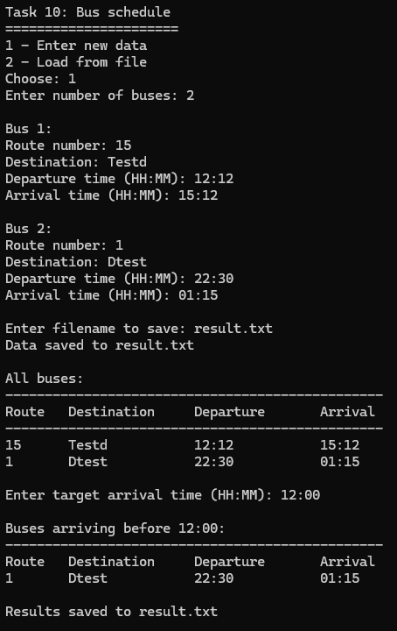

Задание 2
Вариант 3
Код программы
void task_8() {
double a = -0.9;
double b = 0.9;
double h = (b - a) / 10;
double epsilon = 1e-3;
std::cout << "Table of Y(x) and S(x)" << std::endl;
std::cout << "=====================================" << std::endl;
std::cout << "a = " << a << ", b = " << b << ", h = " << h << std::endl;
std::cout << "e = " << epsilon << std::endl;
std::cout << "-------------------------------------" << std::endl;
std::cout << "x\t\tY(x)\t\tS(x)\t\tn" << std::endl;
std::cout << "-------------------------------------" << std::endl;
for (double x = a; x <= b + h / 2; x += h) {
double y = pow(1 + x, 1.0 / 3.0);
double s = 1.0 + x / 3.0;
double term = x / 3.0;
int k = 2;
int n = 0;
while (k <= 1000) {
term = term * (-1) * (3 * k - 4) * (k - 1) * x / (3 * k * k);
s += term;
n = k;
if (fabs(term) < epsilon) {
break;
}
k++;
}
std::cout << x << "\t\t" << y << "\t\t" << s << "\t\t" << n << std::endl;
}
}

Пример вывода программы
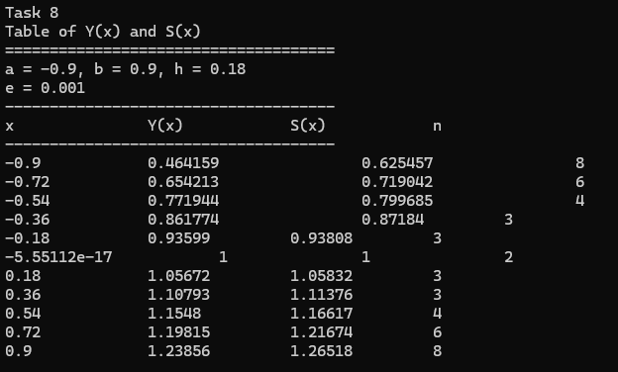

Задание 3
Вариант 3
Код программы
void task_9() {
int number;
std::cout << "Count digits in a number" << std::endl;
std::cout << "==================================" << std::endl;
std::cout << "Enter a number: ";
std::cin >> number;
int count = 0;
int temp = abs(number);
if (temp == 0) {
count = 1;
}
else {
while (temp > 0) {
temp /= 10;
count++;
}
}
std::cout << "Number of digits in " << number << ": " << count << std::endl;
}
Пример вывода программы
